# Expert opinion on the severity of individual symptoms in anaphylaxis

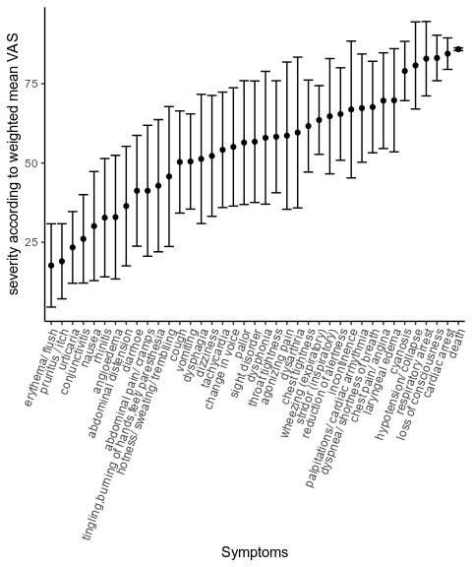

We recived answers from 31 experts with a mean experience of 11.79 years (SD = 11.07) from 11 countries.

The table below summarizes the expert group.

Summary statistics for the expert panel according to country of origin

|  |  |  |  |  |
| --- | --- | --- | --- | --- |
| Country | n | mean experience [y] | mean VAS across all questions | SD VAS |
| Brazil | 1 | 2.00 | 54.18 | 21.47 |
| Bulgaria | 1 | 27.00 | 68.26 | 15.91 |
| France | 1 | 9.00 | 66.46 | 20.59 |
| Germany | 12 | 12.57 | 48.98 | 25.41 |
| Greece | 1 | 4.00 | 47.08 | 31.18 |
| Ireland | 2 | 3.50 | 49.55 | 24.40 |
| Italy | 2 | 17.00 | 60.07 | 19.17 |
| Poland | 3 | 13.67 | 49.02 | 26.13 |
| Spain | 4 | 14.00 | 55.41 | 25.21 |
| Switzerland | 3 | 7.67 | 53.82 | 24.39 |
| x | 1 | NaN | 55.46 | 25.60 |